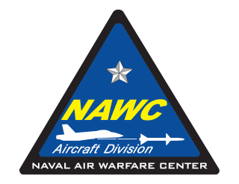
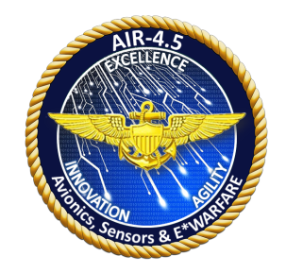
NAWCAD 4.5 Summer Internships
Student Application Form
(U.S. Citizenship Required)
Applications are due by March 15, 2018

AESIP: July 10 – July 27, 2018
(Aviation Electronics and Sensors Internship Program)
RADIATE: July 30 – August 17, 2018
(Radio Frequency and Antenna Demonstration and Instruction for Advancing Technology Education)
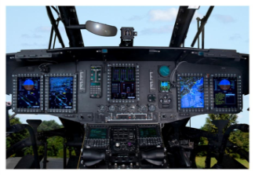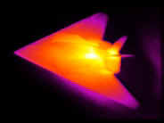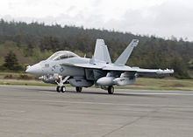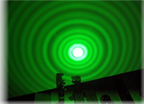

The following are available unpaid internship opportunities:
Opportunity (A) AESIP: For rising high school seniors or rising college freshmen to gain exposure to many of the different technologies that the 4.5 Avionics, Sensors & E*Warfare Department develops every day. This program will give theory and hands on experience in many technology areas such as unmanned aircraft systems, electro-optics sensors, night vision goggles, communications, radio waves theory, optical fiber networks, SONAR, LASERS, radios, RADAR and Cyber systems and more. This program will help guide you in the selection of various technologies and career STEM related fields during your upcoming College years and multiple summer intern programs.
The AESIP internship is from July 10 – July 27 from 0800-1600 and fulfills the 100 hour STEM requirement.
Have you ever wanted to:
Fly a UAV drone? Build and test a radio? Work in the dark with night vision goggles?
Map objects underwater with LASERS? Use an actual SONAR system?
Build and test a working RADAR? Be a CSI with an infra-red camera system?
Understand Cyber Security challenges? Visit the Naval Test Pilot School and see their unique aircraft?
Get up close to a real P-8, H-60, multiple UAVs platforms and F/A-18 Hornet fighter jet?
Opportunity (B) RADIATE: For rising high school seniors or rising college freshmen to learn about radio waves and radar technologies and how the United States Navy develops, tests and uses these technologies on board their aircraft platforms. This unique internship combines a curriculum developed and taught by Naval Air Warfare Center Aircraft Division (NAWCAD) radar engineers with hands-on learning, tours of NAWCAD labs, and panels with NAWCAD engineers and scientists.
The RADIATE internship is from July 30 – August 17 from 0800-1600 and fulfills the 100 hour STEM requirement.
How to apply:
All interested students should complete, sign and submit this application
(including written statement) in PDF format to:
Mr. Gerard Walles, NAWCAD 4.5 Z-Code & Ms. Terri Chase, Education Outreach Office
E-mails: gerard.walles@navy.mil; theresa.chase.ctr@navy.mil Rev 6
NAWCAD 4.5 Summer Internship Application Form
Applications are due by March 15, 2018
Accepted students will be notified no later than April 6, 2018

Which unpaid program are you interested in attending: 1st Choice 2nd Choice
AESIP AESIP
RADIATE RADIATE

Student Information: Please print clearly

First Name: ____________________________ Last Name: _________________________________________

School: ______________________________________________________ Grade: _________ GPA: _______

Email: _____________________________________ Parent/Guardian Email: ___________________________

Have you ever participated in NAWC-AD Internship Program? Yes No

Please provide a written statement (max 300 words) that explains your interest in the 4.5 Summer Internship Programs and attach it to your completed application.

Background:
Please mark which classes you will have completed by June 2018:

Computer Science Geometry Calculus 2 Other Technical Course

Algebra 1 Pre-Calculus Physics Other Technical Course

Algebra 2 Calculus 1 AP Physics Other Technical Course

Math or Science Teacher Endorsement Statement:

Teacher First Name: _________________________ Teacher Last Name: _______________________________

School: _______________________________________ Subject: _____________________________________

Email: _____________________________________________________________________________________

Endorsement Statement: _______________________________________________________________________

___________________________________________________________________________________________

Teacher
Endorsement
Signature:
Name (please print) Signature Date

Student Signature:
Name (please print) Signature Date

Parent/Guardian
Signature:
Name (please print) Signature Date

